

网络排查模型
（V1.0）

国家体育总局体育彩票管理中心
技术中心

作者(或修订人) | 版本号 | 日期 | 修改内容与原因
王子 | V1.0 | 2022年7月14日 | 创建

目 录
1. 概述 4
1.1. 目的 4
1.2. 适用范围 4
2. 故障发现 4
3. 故障处理 7
1.3. 设备硬件故障 7
1.3.1. 检查方式 7
1.3.2. 应急处理步骤 30
1.4. 设备假活 30
1.4.1. 检查方式 30
1.4.2. 应急处理步骤 40
1.5. 外部链路 40
1.5.1. 检查方式 42
1.5.2. 应急处理步骤 46
1.6. 路由 46
1.6.1. 检查方式 51
1.6.2. 应急处理步骤 53
1.7. 负载均衡 53
1.7.1. 检查方式 53
1.7.2. 应急处理步骤 54

概述
- 目的
该文档用于生产系统在日常运行发生故障时，指导相关技术人员进行初步故障排查使用。
适用人员为一线以及二线值班人员。

- 适用范围
生产环境网络。

故障发现
在故障发生时，需第一时间查看监控信息：
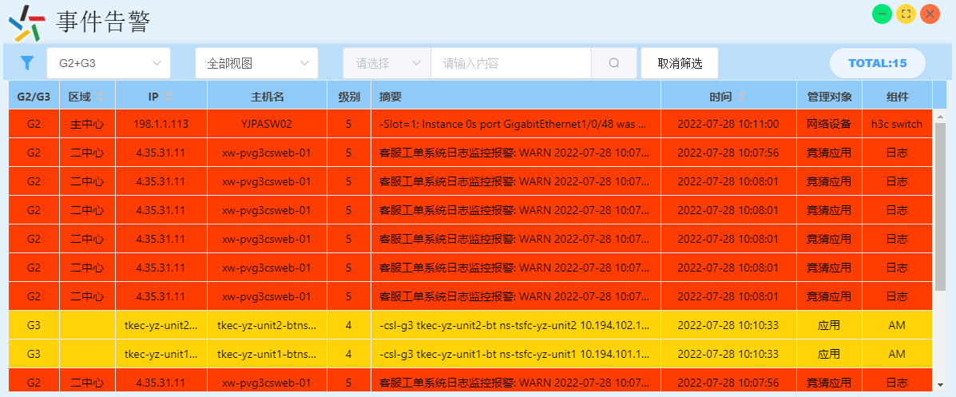
1、事件告警平台：
通过该告警平台可查看设备具体的告警日志、设备地点、管理IP地址、主机名。

2、乐透系统及省中心故障登录Solarwinds查看告警信息：
http:// 198.3.11.10:8080
通过该监控查看省中心设备的状态及数据端专线的状态。
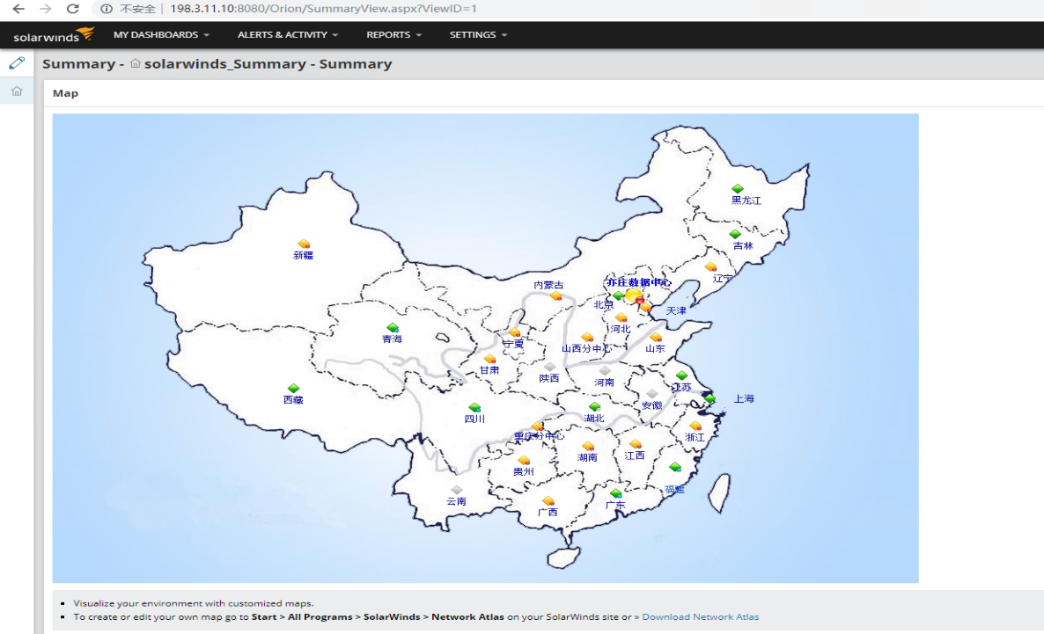
3、竞猜系统登录Solarwinds查看告警信息：
http://4.176.28.1:8090
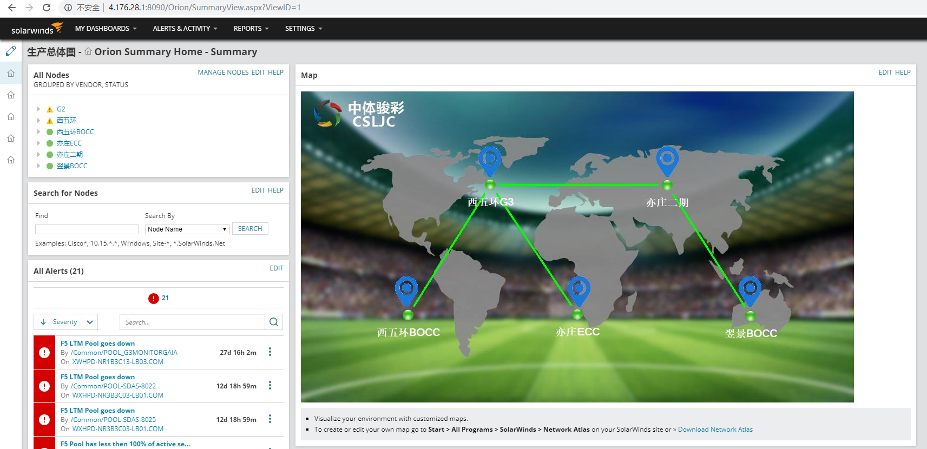
通过该监控查看竞猜系统网络设备的状态。

4、亦庄至西五环DWDM监控：
https://4.255.201.101:31943
NCE的主操作界面分为网络管理、数据采集、告警监控、安全管理、系统设计，点击告警监控查看当前告警日志。

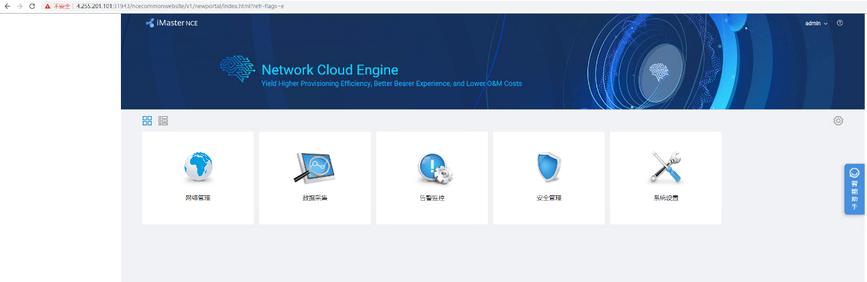
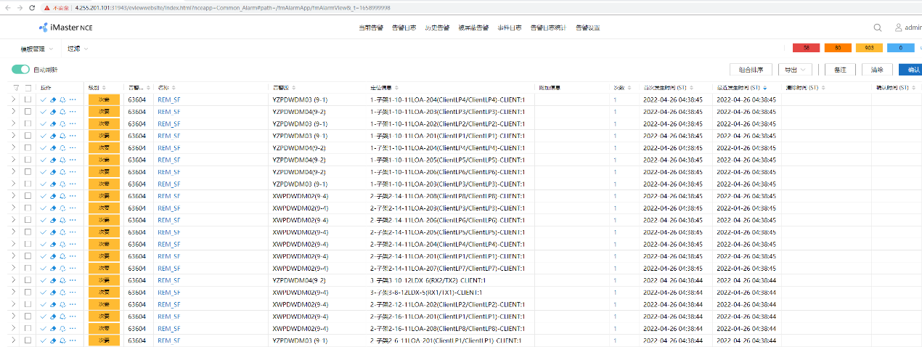
5、翌景至亦庄DWDM监控：
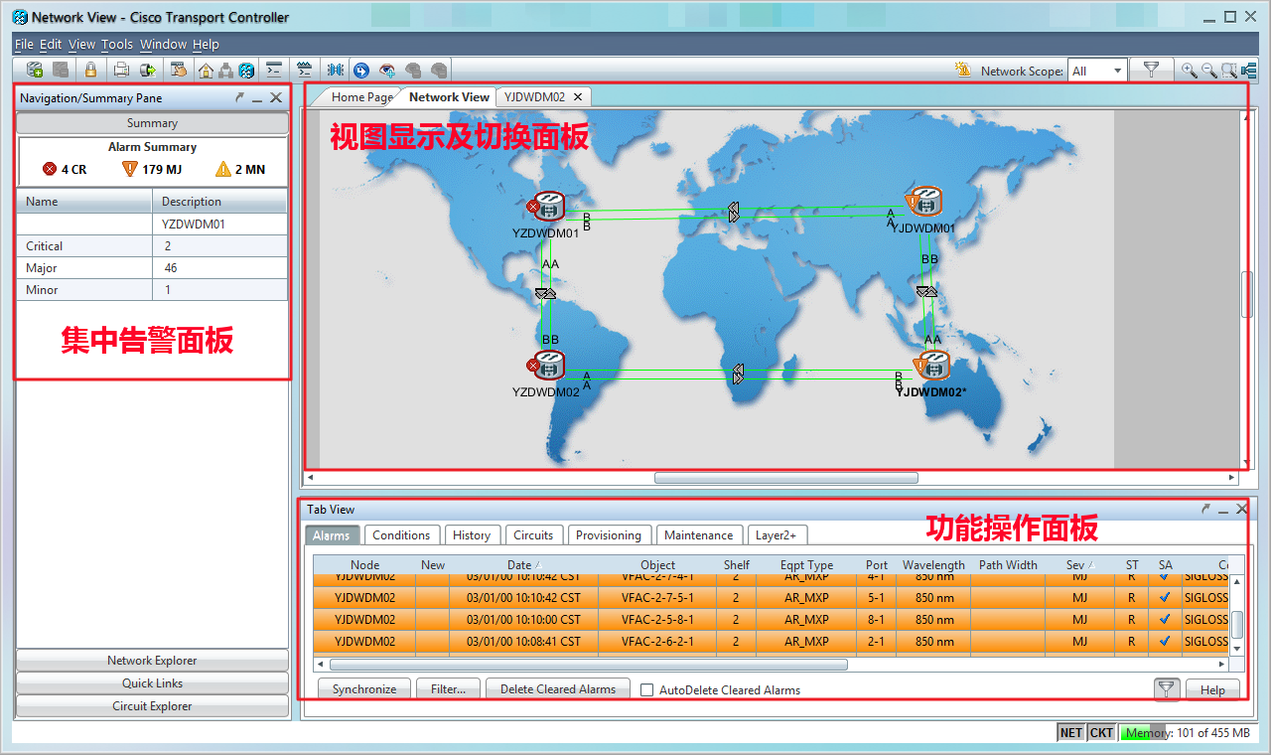
CTC的主操作界面见下图，分为三大显示区域：集中告警面板、操作显示及切换面板、功能操作面板。

- 集中告警面板，显示全部DWDM设备的告警数量。
- 视图显示及切换面板，通过三种视图显示所有DWDM的状态和可操作内容。
- 功能操作面板，对应到每个视图，显示不同的视图下可进行的功能操作。

功能操作虽然在不同的视图下有不同的显示，但通常会具有如下几个Tab：
- Alarms，告警显示。
- Provisioning，配置操作。
- Maintenance，维护信息显示。
- Performance，性能信息显示。

故障处理
- 设备硬件故障
生产网网络设备均为冗余结构，并且部署了HA、堆叠、动态路由等协议，单台设备故障不会导致业务中断。
如设备硬件故障或导致无法远程维护，可通过console登陆进行信息采集及判断。需联系西五环现场人员执行。
- 首先查看设备日志，查看有无硬件告警信息；
- 查看引擎、板卡、CPU、内存、电源、风扇等信息。正常状态为Normal、Online、Fine，若存在unknown、无序列号等现象，则设备硬件存在故障。
    - 检查方式
      - 交换机
        - 华为设备
<XWHPCSW01>display device
CE12808E's Device status:
------------------------------------------------------------------------------------------------------------------------------------------
Slot Card Type Online Power Register Alarm Primary
-------------------------------------------------------------------------------------------------------------------------------------------
1 - CEL36LQED-E Present On Registered Normal NA
2 - CEL36LQED-E Present On Registered Normal NA
7 - CEL48XSED-E Present On Registered Normal NA
8 - CEL48XSED-E Present On Registered Normal NA
9 - CE-MPUA-E Present On Registered Normal Master
10 - CE-MPUA-E Present On Registered Normal Slave
11 - CE-SFU08C-E Present On Registered Normal NA
12 - CE-SFU08C-E Present On Registered Normal NA
13 - CE-SFU08C-E Present On Registered Normal NA
14 - CE-SFU08C-E Present On Registered Normal NA
15 - CE-SFU08C-E Present On Registered Normal NA
16 - CE-SFU08C-E Present On Registered Normal NA
PWR1 - PAC3000S54 Present On Registered Normal NA
PWR2 - PAC3000S54 Present On Registered Normal NA
PWR3 - PAC3000S54 Present On Registered Normal NA
PWR4 - PAC3000S54 Present On Registered Normal NA
PWR5 - PAC3000S54 Present On Registered Normal NA
PWR6 - PAC3000S54 Present On Registered Normal NA
PWR7 - PAC3000S54 Present On Registered Normal NA
<XWHPCSW01>display device power
-----------------------------------------------------------------------------
PowerNo Present Mode State Current Voltage ActualPower RatedPower
(Ampere) (Volt) (Watts) (Watts)
-----------------------------------------------------------------------------
PWR1 YES AC Supply 3.6 53.5 197 3000
PWR2 YES AC Supply 3.5 53.5 191 3000
PWR3 YES AC Supply 3.7 53.5 201 3000
PWR4 YES AC Supply 3.3 53.5 178 3000
PWR5 YES AC Supply 3.6 53.5 193 3000
PWR6 YES AC Supply 3.0 53.5 162 3000
PWR7 YES AC Supply 3.3 53.5 181 3000
PWR8 YES AC Supply 3.0 53.5 166 3000
-----------------------------------------------------------------------------
N/A:Power not available
<XWHPCSW01>display device fan
---------------------------------------------------------------------------------
FanId FanNum Present Register Status Speed Mode Airflow Direction
---------------------------------------------------------------------------------
FAN1 [1-2] YES YES Normal 40%(4100) Auto Front-to-Back
1 4600
2 3600
FAN2 [1-2] YES YES Normal 40%(4100) Auto Front-to-Back
1 4600
2 3600
FAN3 [1-2] YES YES Normal 40%(4100) Auto Front-to-Back
1 4600
2 3600
FAN4.1 [1-2] YES YES Normal 40%(4200) Auto Front-to-Back
1 4500
2 3900
FAN4.2 [1-2] YES YES Normal 38%(4000) Auto Front-to-Back
1 4300
2 3700
FAN4.3 [1-2] YES YES Normal 38%(4000) Auto Front-to-Back
1 4300
2 3700
FAN4.4 [1-2] YES YES Normal 40%(4300) Auto Front-to-Back
1 4600
2 4000
FAN5.1 [1-2] YES YES Normal 40%(4200) Auto Front-to-Back
1 4500
2 3900
FAN5.2 [1-2] YES YES Normal 38%(3950) Auto Front-to-Back
1 4200
2 3700
FAN5.3 [1-2] YES YES Normal 38%(4050) Auto Front-to-Back
1 4400
2 3700
FAN5.4 [1-2] YES YES Normal 40%(4250) Auto Front-to-Back
1 4600
2 3900
---------------------------------------------------------------------------------
N/A:Fan not available
<XWHPCSW01>display cpu
CPU utilization statistics at 2022-07-31 09:56:29 963 ms
System CPU Using Percentage : 5%
CPU utilization for five seconds: 5%, one minute: 5%, five minutes: 5%.
Max CPU Usage : 33%
Max CPU Usage Stat. Time : 2019-08-30 03:39:24 511 ms
State: Non-overload
Overload threshold: 90%, Overload clear threshold: 75%, Duration: 480s
---------------------------
ServiceName UseRate
---------------------------
SYSTEM 5%
AAA 0%
ARP 0%
CMF 0%
DEVICE 0%
EUM 0%
FEA 0%
FEC 0%
FIBRESM 0%
IFM 0%
IP STACK 0%
LDT 0%
LLDP 0%
LOCAL PKT 0%
MSTP 0%
ND 0%
NETSTREAM 0%
OAM 0%
OSPF 0%
PEM 0%
PNP 0%
RGM 0%
RM 0%
SLA 0%
SMLK 0%
STACKMNG 0%
SVRO 0%
TNLM 0%
TUNNEL 0%
VLAN 0%
---------------------------
CPU Usage Details
----------------------------------------------------------------
CPU Current FiveSec OneMin FiveMin Max MaxTime
----------------------------------------------------------------
cpu0 8% 8% 8% 10% 54% 2019-08-30 03:39:02
cpu1 5% 4% 4% 5% 49% 2019-08-30 03:39:02
cpu2 6% 6% 6% 5% 52% 2019-08-30 03:39:02
cpu3 4% 4% 3% 4% 50% 2019-08-30 03:39:02
cpu4 4% 3% 4% 5% 49% 2019-08-30 03:39:02
cpu5 6% 9% 7% 6% 47% 2019-08-30 03:39:02
cpu6 8% 8% 9% 7% 50% 2019-08-30 03:39:02
cpu7 6% 5% 6% 5% 47% 2019-08-30 03:39:02
<XWHPCSW01>display memory
Memory utilization statistics at 2022-07-31 09:57:57 456 ms
System Total Memory: 8049784 Kbytes
Total Memory Used: 1150944 Kbytes
Memory Using Percentage: 14%
State: Non-overload
Overload threshold: 95%, Overload clear threshold: 75%, Duration: 2s
----------------------------
ServiceName MemUsage(KB)
----------------------------
CMF 323862
FEA 70193
SYSTEM 26475
IFM 15314
FEC 13555
DEVICE 7554
STACKMNG 6056
IP STACK 4291
VLAN 2805
AAA 2426
OSPF 1509
RM 1126
MSTP 725
LOCAL PKT 555
ARP 403
LDT 254
OAM 240
FIBRESM 184
EUM 174
SLA 167
NETSTREAM 108
ND 94
TNLM 78
SMLK 72
TUNNEL 68
LLDP 63
PNP 48
RGM 39
PEM 0
----------------------------
        - 华三设备
<XWHPD-NC1COL-SW01>display device
Slot Type State Subslot Soft Ver Patch Ver
1/0 LSXM1QGS36HB1 Normal 0 S12504X-AF-2713 P013
1/1 LSXM1QGS36HB1 Normal 0 S12504X-AF-2713 P013
1/2 LSXM1TGS48HB1 Normal 0 S12504X-AF-2713 P013
1/3 LSXM1TGS48HB1 Normal 0 S12504X-AF-2713 P013
1/4 LSXM1SUP04B1 Master 0 S12504X-AF-2713 P013
1/5 LSXM1SUP04B1 Standby 0 S12504X-AF-2713 P013
1/6 LSXM1SFH04D1 Normal 0 S12504X-AF-2713 P013
1/7 LSXM1SFH04D1 Normal 0 S12504X-AF-2713 P013
1/8 LSXM1SFH04D1 Normal 0 S12504X-AF-2713 P013
1/9 LSXM1SFH04D1 Normal 0 S12504X-AF-2713 P013
1/10 LSXM1SFH04D1 Normal 0 S12504X-AF-2713 P013
1/11 LSXM1SFH04D1 Normal 0 S12504X-AF-2713 P013
2/0 LSXM1QGS36HB1 Normal 0 S12504X-AF-2713 P013
2/1 LSXM1QGS36HB1 Normal 0 S12504X-AF-2713 P013
2/2 LSXM1TGS48HB1 Normal 0 S12504X-AF-2713 P013
2/3 LSXM1TGS48HB1 Normal 0 S12504X-AF-2713 P013
2/4 LSXM1SUP04B1 Standby 0 S12504X-AF-2713 P013
2/5 LSXM1SUP04B1 Standby 0 S12504X-AF-2713 P013
2/6 LSXM1SFH04D1 Normal 0 S12504X-AF-2713 P013
2/7 LSXM1SFH04D1 Normal 0 S12504X-AF-2713 P013
2/8 LSXM1SFH04D1 Normal 0 S12504X-AF-2713 P013
2/9 LSXM1SFH04D1 Normal 0 S12504X-AF-2713 P013
2/10 LSXM1SFH04D1 Normal 0 S12504X-AF-2713 P013
2/11 LSXM1SFH04D1 Normal 0 S12504X-AF-2713 P013
<XWHPD-NC1COL-SW01>display power
Chassis 1:

Power supply policy : Enabled
Surplus sleeping : Disabled
Power modules installed : 4
Power modules usable : 4
Total power : 9600W
Redundant power : 0W
Sleeping power : 0W
Available power : 9600W
Allocated power : 3270W
Remaining power : 6330W

PowerID State InPower(W) Current(A) Voltage(V) OutPower(W) Type
1 Normal 2400 7.00 53.72 376.04 PSR2400-54A
2 Normal 2400 7.25 53.72 389.47 PSR2400-54A
3 Normal 2400 6.50 53.74 349.31 PSR2400-54A
4 Normal 2400 7.25 53.84 390.34 PSR2400-54A

Information about reserved power:

Slot Status Power(W) Remarks
0 Normal 600 Powered on
1 Normal 600 Powered on
2 Normal 300 Powered on
3 Normal 300 Powered on
4 Normal 50 Reserved for MPU
5 Normal 50 Reserved for MPU
6 Normal 140 Powered on
7 Normal 140 Powered on
8 Normal 140 Powered on
9 Normal 140 Powered on
10 Normal 140 Powered on
11 Normal 140 Powered on

Power information for fans:
Fan[1]: 260W
Fan[2]: 260W

Chassis 2:

Power supply policy : Enabled
Surplus sleeping : Disabled
Power modules installed : 4
Power modules usable : 4
Total power : 9600W
Redundant power : 0W
Sleeping power : 0W
Available power : 9600W
Allocated power : 3270W
Remaining power : 6330W

PowerID State InPower(W) Current(A) Voltage(V) OutPower(W) Type
1 Normal 2400 7.00 53.82 376.74 PSR2400-54A
2 Normal 2400 7.25 53.81 390.12 PSR2400-54A
3 Normal 2400 7.25 53.78 389.90 PSR2400-54A
4 Normal 2400 6.50 53.77 349.50 PSR2400-54A

Information about reserved power:

Slot Status Power(W) Remarks
0 Normal 600 Powered on
1 Normal 600 Powered on
2 Normal 300 Powered on
3 Normal 300 Powered on
4 Normal 50 Reserved for MPU
5 Normal 50 Reserved for MPU
6 Normal 140 Powered on
7 Normal 140 Powered on
8 Normal 140 Powered on
9 Normal 140 Powered on
10 Normal 140 Powered on
11 Normal 140 Powered on

Power information for fans:
Fan[1]: 260W
Fan[2]: 260W
<XWHPD-NC1COL-SW01>display fan
Chassis 1:
Fan-tray 1:
Status : Normal
Fan Type : LSXM104XFAN
Fan number: 2
Fan mode : Auto
Airflow Direction: Front-to-back
Fan Speed(rpm)
--- ----------
1 3640
2 3690
Fan-tray 2:
Status : Normal
Fan Type : LSXM104XFAN
Fan number: 2
Fan mode : Auto
Airflow Direction: Front-to-back
Fan Speed(rpm)
--- ----------
1 3658
2 3705

Chassis 2:
Fan-tray 1:
Status : Normal
Fan Type : LSXM104XFAN
Fan number: 2
Fan mode : Auto
Airflow Direction: Front-to-back
Fan Speed(rpm)
--- ----------
1 3690
2 3667
Fan-tray 2:
Status : Normal
Fan Type : LSXM104XFAN
Fan number: 2
Fan mode : Auto
Airflow Direction: Front-to-back
Fan Speed(rpm)
--- ----------
1 3640
2 3624
<XWHPD-NC1COL-SW01>display cpu summary
Chassis Slot CPU Last 5 sec Last 1 min Last 5 min
1 0 0 5% 5% 5%
1 1 0 5% 5% 5%
1 2 0 4% 4% 4%
1 3 0 3% 4% 4%
1 4 0 1% 1% 1%
1 5 0 0% 1% 1%
1 6 0 0% 0% 0%
1 7 0 0% 0% 0%
1 8 0 0% 0% 0%
1 9 0 0% 0% 0%
1 10 0 0% 0% 0%
1 11 0 0% 0% 0%
2 0 0 5% 5% 5%
2 1 0 5% 5% 5%
2 2 0 3% 4% 4%
2 3 0 3% 4% 4%
2 4 0 0% 0% 0%
2 5 0 0% 0% 0%
2 6 0 0% 0% 0%
2 7 0 0% 0% 0%
2 8 0 0% 0% 0%
2 9 0 0% 0% 0%
2 10 0 0% 0% 0%
2 11 0 0% 0% 0%
<XWHPD-NC1COL-SW01>display memory summary
Memory statistics are measured in KB:
Chassis Slot CPU Total Used Free Buffers Caches FreeRatio
1 0 0 16518560 2616016 13902544 32 235456 84.2%
1 1 0 16518560 2615008 13903552 32 235456 84.2%
1 2 0 8180528 2283696 5896832 32 235440 72.2%
1 3 0 8180528 2275936 5904592 32 235328 72.2%
1 4 0 16518048 2649568 13868480 64 573680 85.1%
1 5 0 16518048 2349744 14168304 64 380816 85.8%
1 6 0 4109136 1535904 2573232 0 235392 62.8%
1 7 0 4109136 1535776 2573360 0 235392 62.8%
1 8 0 4109136 1531744 2577392 0 235392 62.9%
1 9 0 4109136 1534992 2574144 0 235392 62.8%
1 10 0 4109136 1531424 2577712 0 235392 62.9%
1 11 0 4109136 1531504 2577632 0 235392 62.9%
2 0 0 16518560 2618624 13899936 32 235440 84.2%
2 1 0 16518560 2624064 13894496 32 235440 84.2%
2 2 0 8180528 2293008 5887520 32 235424 72.0%
2 3 0 8180528 2281024 5899504 32 235424 72.2%
2 4 0 16518048 2367248 14150800 64 390384 85.7%
2 5 0 16518048 2358064 14159984 64 380720 85.7%
2 6 0 4109136 1532208 2576928 0 235392 62.9%
2 7 0 4109136 1530992 2578144 0 235392 62.9%
2 8 0 4109136 1544400 2564736 0 235376 62.6%
2 9 0 4109136 1536016 2573120 0 235392 62.8%
2 10 0 4109136 1531744 2577392 0 235392 62.9%
2 11 0 4109136 1534960 2574176 0 235376 62.8%

      - 路由器
        - 华为设备
<XWPCRT01>display device
NE40E-X8's Device status:
-------------------------------------------------------------------------------
Slot # Type Online Register Status Role LsId Primary
-------------------------------------------------------------------------------
1 LPU Present Registered Normal LC 0 NA
2 LPU Present Registered Normal LC 0 NA
9 MPU Present Registered Normal MMB 0 Master
10 MPU Present Registered Normal MMB 0 Slave
11 SFU Present Registered Normal OTHER 0 NA
12 SFU Present Registered Normal OTHER 0 NA
13 SFU Present Registered Normal OTHER 0 NA
14 CLK Present Registered Normal OTHER 0 Master
15 CLK Present Registered Normal OTHER 0 Slave
16 PWR Present Registered Normal OTHER 0 NA
17 PWR Present Registered Normal OTHER 0 NA
18 FAN Present Registered Normal OTHER 0 NA
19 FAN Present Registered Normal OTHER 0 NA
<XWPCRT01>display power
AC:
No. Present Mode State Num
-------------------------------------------------------------------------------
16 Yes AC Normal Abnormal(0)/Normal(2)
17 Yes AC Normal Abnormal(0)/Normal(2)
Power monitor cable state:
Plug

PEM:
No. Present Mode State Num
-------------------------------------------------------------------------------
16 Yes DC Normal Abnormal(0)/Normal(2)
17 Yes DC Normal Abnormal(0)/Normal(2)
Power monitor cable state:
Plug
<XWPCRT01>display fan
Slotid : 18
Present : YES
Registered: YES
Status : AUTO
FanSpeed : [No.]Speed
[1] 50%
Slotid : 19
Present : YES
Registered: YES
Status : AUTO
FanSpeed : [No.]Speed
[1] 50%
<XWPCRT01>display cpu-usage
Cpu utilization statistics at 2022-07-31 10:03:02 937 ms
System cpu use rate is : 25%
Cpu utilization for five seconds: 25% ; one minute: 24% ; five minutes: 23%.
Max CPU Usage : 99%
Max CPU Usage Stat. Time : 2019-08-01 00:51:26 580 ms
---------------------------
ServiceName UseRate
---------------------------
SYSTEM 18%
CMF 7%
AAA 0%
ARP 0%
BRAS 0%
DEVICE 0%
DHCP 0%
ETRUNK 0%
EUM 0%
FEA 0%
FEC 0%
FIBRESM 0%
IFM 0%
IP STACK 0%
LDT 0%
LINK 0%
LOCAL PKT 0%
MFLP 0%
MSTP 0%
ND 0%
NETSTREAM 0%
OAM 0%
OSPF 0%
PKI 0%
PNP 0%
PTPA 0%
RBS 0%
RGM 0%
RM 0%
SLA 0%
SMLK 0%
SVRO 0%
TNLM 0%
TUNNEL 0%
VLAN 0%
---------------------------
CPU Usage Details
----------------------------------------------------------------
CPU Current FiveSec OneMin FiveMin Max MaxTime
----------------------------------------------------------------
cpu0 24% 23% 22% 22% 99% 2019-08-01 00:51:12
cpu1 26% 27% 26% 24% 99% 2019-08-01 00:51:33
----------------------------------------------------------------
<XWPCRT01>display memory-usage
Memory utilization statistics at 2022-07-31 10:05:00 279 ms
System Total Memory Is: 4093596 Kbytes
Total Memory Used Is: 1292284 Kbytes
Memory Using Percentage Is: 31%
----------------------------------------
Process memory information in the slot:
----------------------------------------
ProcessId ProcessName Used(Kbytes)
----------------------------------------
1002 PROTO4 91922
1001 RESP 58023
1000 PROTO5 32102
1004 FESMB 55228
4 LM 44407
3 CFG 584699
10001 PROTO1 36173
2 SM 31066
1003 PSM1 66000
1005 PSM2 23885
1006 OPS 18243
0 system 250536
----------------------------------------

      - 防火墙
        - 山石设备
XWPAFW01(M)# show environment

Both the temperature and fan are in normal state.

Temperature information(C):
========================================
Description Temperature Range
----------------------------------------
CPU 30 0-90
Chassis_Outlet 32 0-90
Chassis_Inlet 22 0-90
Switch 57 0-110
Slot_Inlet 25 0-90
----------------------------------------

Fan information:
========================================
Description Status
----------------------------------------
Fan Fine
----------------------------------------

Power information:
========================================
Description Status
----------------------------------------
PS0 Fine
PS1 Fine
----------------------------------------
XWPAFW01(M)# show module
Slot State Module Type Serial Number
---- ------------ ---------------- ----------------
1 Empty
2 Empty
3 Empty
4 Online IOC-4SFP+-M 2809846172007559
XWPAFW01(M)# show cpu
Average cpu utilization : 5.1%
Current cpu utilization : 6.2%
Last 1 minute : 6.5%
Last 5 minutes : 6.5%
Last 15 minutes : 6.4%
XWPAFW01(M)# show memory
The percentage of memory utilization: 21%
total(KB) used(KB) free(KB)
8388608 1765475 6623133

        - 华三设备
<XWHPD-NE1DIL-FW01>display device
Chassis Slot Type State Subslot Soft Ver Patch Ver
1 0 NSQM1MBFEA0 Normal 0 M9010-9141P38 None
NSQM2TG8GP40 1 NONE
NONE Absent 2 NONE
1 1 NONE Absent 0 NONE None
1 2 NONE Absent 0 NONE None
1 3 NONE Absent 0 NONE None
1 4 NSQ1SUPB0 Master 0 M9010-9141P38 None
1 5 NSQ1SUPB0 Standby 0 M9010-9141P38 None
1 6 NSQM1FWDFGC1 Normal 0 M9010-9141P38 None
CPU 1 Normal 0 M9010-9141P38
1 7 NONE Absent 0 NONE None
1 8 NONE Absent 0 NONE None
1 9 NSQM1MBFEA0 Normal 0 M9010-9141P38 None
NSQM2TG8GP40 1 NONE
NONE Absent 2 NONE
1 10 NSQ1FAB08D0 Normal 0 M9010-9141P38 None
1 11 NSQ1FAB08D0 Normal 0 M9010-9141P38 None
1 12 NSQ1FAB08D0 Normal 0 M9010-9141P38 None
1 13 NSQ1FAB08D0 Normal 0 M9010-9141P38 None
2 0 NSQM1MBFEA0 Normal 0 M9010-9141P38 None
NSQM2TG8GP40 1 NONE
NONE Absent 2 NONE
2 1 NONE Absent 0 NONE None
2 2 NONE Absent 0 NONE None
2 3 NONE Absent 0 NONE None
2 4 NSQ1SUPB0 Standby 0 M9010-9141P38 None
2 5 NSQ1SUPB0 Standby 0 M9010-9141P38 None
2 6 NSQM1FWDFGC1 Normal 0 M9010-9141P38 None
CPU 1 Normal 0 M9010-9141P38
2 7 NONE Absent 0 NONE None
2 8 NONE Absent 0 NONE None
2 9 NSQM1MBFEA0 Normal 0 M9010-9141P38 None
NSQM2TG8GP40 1 NONE
NONE Absent 2 NONE
2 10 NSQ1FAB08D0 Normal 0 M9010-9141P38 None
2 11 NSQ1FAB08D0 Normal 0 M9010-9141P38 None
2 12 NSQ1FAB08D0 Normal 0 M9010-9141P38 None
2 13 NSQ1FAB08D0 Normal 0 M9010-9141P38 None
<XWHPD-NE1DIL-FW01>display power
Chassis 1:
Power 0 State: Normal Voltage:12.0 V Current:9.6 A Power:114.5 W
Power 1 State: Normal Voltage:12.0 V Current:9.6 A Power:115.1 W
Power 2 State: Normal Voltage:12.0 V Current:11.4 A Power:136.9 W
Power 3 State: Normal Voltage:12.0 V Current:10.8 A Power:129.5 W
Power 4 State: Normal Voltage:12.0 V Current:11.0 A Power:131.6 W
Power 5 State: Normal Voltage:12.0 V Current:9.7 A Power:116.5 W

Chassis 2:
Power 0 State: Normal Voltage:12.0 V Current:9.1 A Power:109.9 W
Power 1 State: Normal Voltage:12.0 V Current:9.9 A Power:118.9 W
Power 2 State: Normal Voltage:12.0 V Current:10.1 A Power:121.1 W
Power 3 State: Normal Voltage:12.0 V Current:9.4 A Power:112.5 W
Power 4 State: Normal Voltage:12.0 V Current:10.0 A Power:120.1 W
Power 5 State: Normal Voltage:12.0 V Current:12.5 A Power:149.4 W
<XWHPD-NE1DIL-FW01>display fan
Chassis 1:
Fan Frame 0 State: Normal

Chassis 2:
Fan Frame 0 State: Normal
<XWHPD-NE1DIL-FW01>display cpu-usage summary
Chassis Slot CPU Last 5 sec Last 1 min Last 5 min
1 0 0 3% 3% 3%
1 4 0 1% 1% 1%
1 5 0 0% 0% 0%
1 6 0 2% 1% 1%
1 6 1 4% 4% 4%
1 9 0 3% 3% 3%
1 10 0 13% 13% 13%
1 11 0 14% 14% 14%
1 12 0 14% 13% 13%
1 13 0 13% 14% 13%
2 0 0 3% 3% 3%
2 4 0 0% 0% 0%
2 5 0 0% 0% 0%
2 6 0 2% 1% 2%
2 6 1 0% 0% 0%
2 9 0 3% 3% 3%
2 10 0 13% 14% 13%
2 11 0 14% 14% 14%
2 12 0 13% 13% 13%
2 13 0 13% 13% 13%
<XWHPD-NE1DIL-FW01>display memory summary
Memory statistics are measured in KB:
Chassis Slot CPU Total Used Free Buffers Caches FreeRatio
1 0 0 1978216 538628 1439588 0 30360 72.8%
1 4 0 8157740 1680940 6476800 5704 452488 82.2%
1 5 0 8157740 1458412 6699328 2396 303556 83.1%
1 6 0 4054016 513340 3540676 0 68948 87.3%
1 6 1 32870556 9167552 23703004 2728 785788 73.8%
1 9 0 1978216 538948 1439268 0 30360 72.8%
1 10 0 984480 429952 554528 0 24604 56.4%
1 11 0 984480 430800 553680 0 24608 56.3%
1 12 0 984480 429056 555424 0 24604 56.5%
1 13 0 984480 429596 554884 0 24604 56.4%
2 0 0 1978216 540628 1437588 0 30364 72.7%
2 4 0 8157740 1493268 6664472 2396 339592 83.1%
2 5 0 8157740 1454536 6703204 2396 304084 83.1%
2 6 0 4054016 513380 3540636 0 68944 87.3%
2 6 1 32870556 8655124 24215432 2796 317548 73.9%
2 9 0 1978216 540892 1437324 0 30364 72.7%
2 10 0 984480 429436 555044 0 24604 56.4%
2 11 0 984480 430312 554168 0 24604 56.3%
2 12 0 984480 430036 554444 0 24604 56.4%
2 13 0 984480 429764 554716 0 24604 56.4%
      - 负载均衡
[root@XWPBL1-SLB01:Active:In Sync] config # tmsh show sys hardware

Sys::Hardware
Chassis Fan Status
Index Status Low Limit(rpm) Fan Speed(rpm)
1 up 1000 15574
2 up 1000 15913
3 up 1000 15913
4 up 1000 15913

Chassis Information
Maximum MAC Count 2
Registration Key -

Chassis Power Supply Status
Index Status Current
1 up AC
2 up AC

Chassis Temperature Status
Index Lo Limit(C) Temp(degC) Hi Limit(C) Location
1 0 49 85 Main board HSBE transistor temperature
2 0 32 65 Main board HSBE IC temperature
3 0 25 45 Main board inlet transistor temperature
4 0 29 45 Main board inlet IC temperature
5 0 29 55 Main board outlet transistor temperature
6 0 32 55 Main board outlet IC temperature
7 0 35 67 Power supply #1 meas. inlet temperature
8 0 37 67 Power supply #2 meas. inlet temperature
9 0 29 55 Main board near power supplies temperature
10 0 33 85 Main board near B56821 temperature

CPU Status
Index Temp(degC) Fan Speed(rpm)
1 37 15913

Hardware Version Information
Name HD1
Type physical-disk
Model INTEL SSDSC2BA400G3
Parameters -- --
SerialNumber BTTV5484014G400HGN
Size 372.61G
Firmware Version 5DV10272
Media Type SSD

Hardware Version Information
Name cpld
Type pic
Model F5 CPLD
Parameters -- --
version 0x9

Hardware Version Information
Name cpus
Type base-board
Model Intel(R) Xeon(R) CPU E3-1230 V2 @ 3.30GHz
Parameters -- --
cache size 8192 KB
cores 8 (physical:4)
cpu MHz 2100.000
cpu sockets 1
cpu stepping 9

Hardware Version Information
Name hsb_lbb0
Type net
Model F5 High Speed Bridge LBB device
Parameters -- --
version Build: 1.11.25 lab 1

Hardware Version Information
Name lop
Type pic
Model F5
Parameters -- --
Boot loader version 1.05
Firmware version 3.07

Hardware Version Information
Name mainboard
Type base-board
Model F5
Parameters -- --
Assembly serial pca0357z3a94
Board type N/A
PCA PCA-0357-01 REV C
Part Number 205-0369-05 REV G
Revision N/A

Hardware Version Information
Name n3-compress0
Type compress
Model Nitrox 3 Compression Device
Parameters -- --
version PASS 1

Name n3-crypto0
Type crypto
Model Cavium NITROX-3
Parameters -- --
version CNN35x-MC-SSL-0022

Hardware Version Information
Name psu1
Type psu
Model 73-610-125
Parameters -- --
Location 1
Manufacturer ARTESYN
Revision A7
Serial number T50015A7

Name psu2
Type psu
Model 73-610-125
Parameters -- --
Location 2
Manufacturer ARTESYN
Revision A7
Serial number TT00CMA7

root@(XWPBL1-SLB01)(cfg-sync In Sync)(Active)(/Common)(tmos)# show sys cpu

Sys::System CPU Information
-------------------------------------------------------------------
System CPU Usage(%) Current Average Max(since 07/31/22 11:00:00)
-------------------------------------------------------------------
Utilization 32 20 45

----------------------------------------------------------------
Sys::Host CPUs
----------------------------------------------------------------
Host: 0

CPU: 0 (clock ticks) Last 5 sec Last 1 min Last 5 min Total
- (avg/sec) (avg/sec) (avg/sec) -
User 7 6 6 376.6M
Niced 0 0 0 0
System 3 3 3 153.0M
Idle 86 86 86 4.9G
Irq 0 0 0 0
Softirq 0 0 0 317.6K
Iowait 0 0 0 231.4K
Stolen 0 0 0 0
Util% (last 5 sec) - - - 10

CPU: 1 (clock ticks) Last 5 sec Last 1 min Last 5 min Total
- (avg/sec) (avg/sec) (avg/sec) -
User 27 19 14 622.7M
Niced 0 0 1 26.6M
System 8 7 5 246.6M
Idle 64 73 79 4.8G
Irq 0 0 0 0
Softirq 0 0 0 11.1M
Iowait 0 0 0 370.4K
Stolen 0 0 0 0
Util% (last 5 sec) - - - 36

CPU: 2 (clock ticks) Last 5 sec Last 1 min Last 5 min Total
- (avg/sec) (avg/sec) (avg/sec) -
User 6 7 7 393.2M
Niced 0 0 0 0
System 2 2 2 118.8M
Idle 87 87 87 5.0G
Irq 0 0 0 0
Softirq 0 0 0 1.1M
Iowait 0 0 0 152.8K
Stolen 0 0 0 0
Util% (last 5 sec) - - - 9

CPU: 3 (clock ticks) Last 5 sec Last 1 min Last 5 min Total
- (avg/sec) (avg/sec) (avg/sec) -
User 14 17 16 603.3M
Niced 0 1 0 15.9M
System 6 7 5 246.2M
Idle 79 75 78 4.8G
Irq 0 0 0 0
Softirq 0 0 0 5.2M
Iowait 0 0 0 271.7K
Stolen 0 0 0 0
Util% (last 5 sec) - - - 21

CPU: 4 (clock ticks) Last 5 sec Last 1 min Last 5 min Total
- (avg/sec) (avg/sec) (avg/sec) -
User 6 7 7 391.1M
Niced 0 0 0 0
System 2 2 2 121.7M
Idle 87 87 87 5.0G
Irq 0 0 0 0
Softirq 0 0 0 362.0K
Iowait 0 0 0 227.3K
Stolen 0 0 0 0
Util% (last 5 sec) - - - 9

CPU: 5 (clock ticks) Last 5 sec Last 1 min Last 5 min Total
- (avg/sec) (avg/sec) (avg/sec) -
User 13 17 12 597.4M
Niced 0 0 0 15.0M
System 6 7 5 251.9M
Idle 80 75 82 4.8G
Irq 0 0 0 0
Softirq 0 1 0 19.2M
Iowait 0 0 0 303.7K
Stolen 0 0 0 0
Util% (last 5 sec) - - - 19

CPU: 6 (clock ticks) Last 5 sec Last 1 min Last 5 min Total
- (avg/sec) (avg/sec) (avg/sec) -
User 7 7 7 399.4M
Niced 0 0 0 0
System 3 2 2 120.0M
Idle 86 87 87 5.0G
Irq 0 0 0 0
Softirq 0 0 0 151.6K
Iowait 0 0 0 239.8K
Stolen 0 0 0 0
Util% (last 5 sec) - - - 10

CPU: 7 (clock ticks) Last 5 sec Last 1 min Last 5 min Total
- (avg/sec) (avg/sec) (avg/sec) -
User 28 15 12 596.3M
Niced 0 0 0 14.5M
System 11 6 5 255.9M
Idle 61 78 82 4.8G
Irq 0 0 0 0
Softirq 0 0 0 9.2M
Iowait 0 0 0 355.2K
Stolen 0 0 0 0
Util% (last 5 sec) - - - 39
Platform
Name BIG-IP 5050
BIOS Revision OBJ-0482-xx Build: 2.07.215.0 10/14/2015
Base MAC f4:15:63:ba:f8:00
PVA Version 20

System Information
Type C109
Chassis Serial f5-fdnr-tuwb
Level 200/400 Part 205-0369-05 REV G
Switchboard Serial
Switchboard Part Revision
Host Board Serial pca0357z3a94
Host Board Part Revision
root@(XWPBL1-SLB01)(cfg-sync In Sync)(Active)(/Common)(tmos)# show sys memory

Sys::System Memory Information
-----------------------------------------------------------------
Memory Used(%) Current Average Max(since 07/31/22 11:02:18)
-----------------------------------------------------------------
TMM Memory Used 2 2 2
Other Memory Used 78 77 79
Swap Used 6 6 6

------------------------
Sys::Host Memory (bytes)
------------------------
TMM: 0
Total 26.0G
Used 456.4M
Free 25.5G
Other: 0
Total 5.3G
Used 4.1G
Free 1.2G
Total: 0
Total 31.3G
Used 4.5G
Free 26.8G
Swap: 0
Total 5.0G
Used 292.9M
Free 4.7G

      - SSL网关
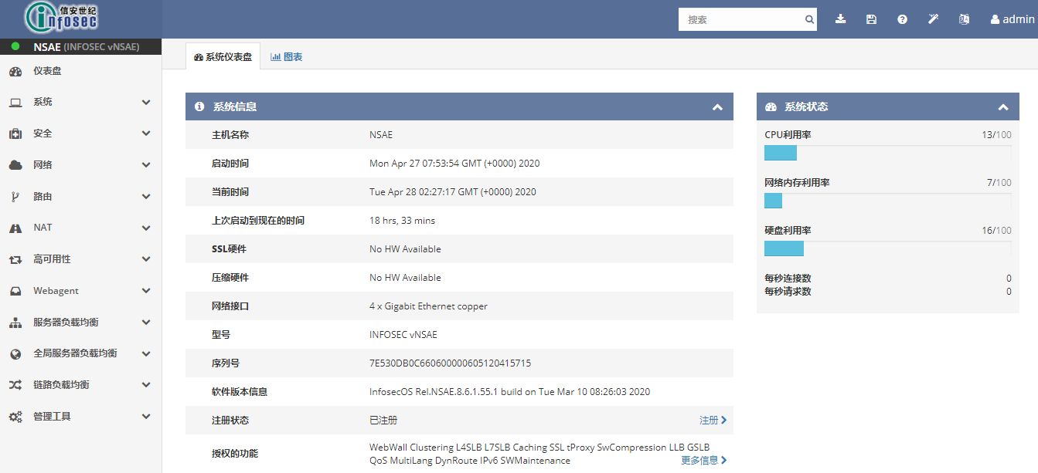
    - 应急处理步骤
生产所有硬件设备都有冗余，硬件故障如彻底故障，则工程师拨打设备服务提供商热线申报硬件故障，安排窗口进行更换。如出现反复重启的情况，第一时间进行关闭隔离。

- 设备假活
    - 检查方式
设备的假活主要现象为设备转发层面出现时断时续，可以通过对硬件状态、温度、电压、接口转发状态以及session连接数大致判断其是否转发层面出现问题。
      - 查看设备的硬件状态
按照设备硬件故障命令查看。
      - 查看设备温度
        - 华为设备
Status：NORMAL，表示温度正常。MAJOR，表示温度超过严重告警阈值。FATAL，表示温度超过致命告警阈值。ABNORMAL，表示温度传感器故障。
<HUAWEI> display device temperature all
---------------------------------------------------------------------
Slot Card SensorID Status Major Fatal Current
(Celsius) (Celsius) (Celsius)
---------------------------------------------------------------------
2 -- 1 NORMAL 80 85 39
-- 2 NORMAL 90 110 47
-- 3 NORMAL 80 85 41
-- 4 NORMAL 90 105 58
-- 5 NORMAL 90 110 50
-- 6 NORMAL 75 80 42
4 -- 1 NORMAL 80 102 42
-- 2 NORMAL 90 110 57
-- 3 NORMAL 80 101 44
-- 4 NORMAL 90 105 60
-- 5 NORMAL 95 110 62
-- 6 NORMAL 75 90 42
-- 7 NORMAL 82 85 47
-- 8 NORMAL 82 85 47
6 -- 1 NORMAL 62 95 35
-- 2 NORMAL 62 93 28
-- 3 NORMAL 87 95 35
-- 4 NORMAL 99 105 47
7 -- 1 NORMAL 65 125 32
8 -- 1 NORMAL 65 125 33
9 -- 1 NORMAL 68 88 43
10 -- 1 NORMAL 68 88 42
11 -- 1 NORMAL 68 88 38
PWR1 -- 1 -- -- -- 45
-- 2 -- -- -- 26
---------------------------------------------------------------------
N/A:Sensor not available

        - 华三设备
<XWHPD-NC1COL-SW01>display environment
System temperature information (degree centigrade):
----------------------------------------------------------------------
Chassis Slot Sensor Temperature Lower Warning Alarm Shutdown
1 0 hotspot 1 35 0 75 90 95
1 0 hotspot 2 35 0 75 90 95
1 0 hotspot 3 34 0 75 90 95
1 1 hotspot 1 35 0 75 90 95
1 1 hotspot 2 36 0 75 90 95
1 1 hotspot 3 34 0 75 90 95
1 2 hotspot 1 29 0 75 90 95
1 2 hotspot 2 32 0 75 90 95
1 2 hotspot 3 32 0 75 90 95
1 3 hotspot 1 28 0 75 90 95
1 3 hotspot 2 31 0 75 90 95
1 3 hotspot 3 33 0 75 90 95
1 4 inflow 1 27 0 48 60 NA
1 4 hotspot 1 33 0 75 90 NA
1 4 hotspot 2 29 0 75 90 NA
1 5 inflow 1 24 0 48 60 NA
1 5 hotspot 1 31 0 75 90 NA

        - 负载均衡
[root@XWPBL1-SLB01:Active:In Sync] config # tmsh show sys hardware

Chassis Temperature Status
Index Lo Limit(C) Temp(degC) Hi Limit(C) Location
1 0 49 85 Main board HSBE transistor temperature
2 0 32 65 Main board HSBE IC temperature
3 0 25 45 Main board inlet transistor temperature
4 0 29 45 Main board inlet IC temperature
5 0 29 55 Main board outlet transistor temperature
6 0 32 55 Main board outlet IC temperature
7 0 35 67 Power supply #1 meas. inlet temperature
8 0 37 67 Power supply #2 meas. inlet temperature
9 0 29 55 Main board near power supplies temperature
10 0 33 85 Main board near B56821 temperature

      - 查看电压状态
Status：NORMAL，表示电压正常。LOWER，表示电压低于告警阈值。UPPER，表示电压高于告警阈值。ABNORMAL，表示电压传感器故障。
        - 华为设备
<HUAWEI> display device voltage all
--------------------------------------------------------------------------------
Slot Card SensorID SensorName Status Upper Lower Current

(Volt) (Volt) (Volt)

--------------------------------------------------------------------------------
1 -- 16 12V NORMAL 14.35 9.54 11.62

-- 17 1.0V_AVS_PP0 NORMAL 1.19 0.80 1.00

-- 18 1.0V_AVS_PP1 NORMAL 1.19 0.80 1.02

-- 19 1.0V_AVS_PP2 NORMAL 1.19 0.80 1.01

-- 20 1.0V_AVS_PP3 NORMAL 1.19 0.80 1.00

-- 21 1.0V_PP0 NORMAL 1.19 0.80 0.99

-- 22 1.0V_PP1 NORMAL 1.19 0.80 0.99

        - 华三设备
<XWHPD-NC1COL-SW01>display power
Chassis 1:

Power supply policy : Enabled
Surplus sleeping : Disabled
Power modules installed : 4
Power modules usable : 4
Total power : 9600W
Redundant power : 0W
Sleeping power : 0W
Available power : 9600W
Allocated power : 3270W
Remaining power : 6330W

PowerID State InPower(W) Current(A) Voltage(V) OutPower(W) Type
1 Normal 2400 7.00 53.78 376.46 PSR2400-54A
2 Normal 2400 7.00 53.72 376.04 PSR2400-54A
3 Normal 2400 6.00 53.74 322.44 PSR2400-54A
4 Normal 2400 7.50 53.84 403.80 PSR2400-54A

Information about reserved power:

Slot Status Power(W) Remarks
0 Normal 600 Powered on
1 Normal 600 Powered on
2 Normal 300 Powered on
3 Normal 300 Powered on
4 Normal 50 Reserved for MPU
5 Normal 50 Reserved for MPU
6 Normal 140 Powered on
7 Normal 140 Powered on
8 Normal 140 Powered on
9 Normal 140 Powered on
10 Normal 140 Powered on
11 Normal 140 Powered on

Power information for fans:
Fan[1]: 260W
Fan[2]: 260W

      - 查看接口转发状态
查看接口input、output数据包是否有增长。
        - 华为设备
<HUAWEI> display interface gigabitethernet 0/0/1
GigabitEthernet0/0/1 current state : UP
Line protocol current state : UP
Description:lineate-port-0
Switch Port, PVID : 1, TPID : 8100(Hex), The Maximum Frame Length is 9216
IP Sending Frames' Format is PKTFMT_ETHNT_2, Hardware address is 1047-80ac-cc60
Last physical up time : 2012-02-10 01:46:35 UTC+08:00
Last physical down time : 2012-02-10 01:46:30 UTC+08:00
Current system time: 2012-02-11 11:11:36+08:00
Port Mode: COMMON COPPER
Speed : 1000, Loopback: NONE
Duplex: FULL, Negotiation: ENABLE
Mdi : AUTO
Last 300 seconds input rate 80 bits/sec, 0 packets/sec
Last 300 seconds output rate 152 bits/sec, 0 packets/sec
Input peak rate 57064 bits/sec,Record time: 2012-02-10 07:43:17
Output peak rate 39872 bits/sec,Record time: 2012-02-11 11:11:36

Input: 71004 packets, 9224321 bytes
Unicast: 20023, Multicast: 49102
Broadcast: 1879, Jumbo: 0
Discard: 0, Total Error: 0

CRC: 0, Giants: 0
Jabbers: 0, Throttles: 0
Runts: 0, Alignments: 0
Symbols: 0, Ignoreds: 0
Frames: 0

Output: 20221 packets, 1679706 bytes
Unicast: 19989, Multicast: 0
Broadcast: 232, Jumbo: 0
Discard: 0, Total Error: 0

Collisions: 0, ExcessiveCollisions: 0
Late Collisions: 0, Deferreds: 0

Input bandwidth utilization threshold : 100.00%
Output bandwidth utilization threshold: 100.00%
Input bandwidth utilization : 0.01%
Output bandwidth utilization : 0.01%

        - 华三设备
<XWHPD-NC1COL-SW01>display interface Ten-GigabitEthernet 1/2/0/2
Ten-GigabitEthernet1/2/0/2
Current state: UP
Line protocol state: UP
Description: "TO-YZPD-NC1COL-SW01-Block5 T1/2/0/2"
Bandwidth: 10000000 kbps
Maximum transmission unit: 1500
Allow jumbo frames to pass
Broadcast max-ratio: 100%
Unknown-multicast max-ratio: 100%
Unicast max-ratio: 100%
Internet protocol processing: Disabled
IP packet frame type: Ethernet II, hardware address: 7485-c41a-b601
IPv6 packet frame type: Ethernet II, hardware address: 7485-c41a-b601
Media type is optical fiber, port hardware type is 10G_BASE_SR_SFP
Ethernet port mode: LAN
Port priority: 0
10Gbps-speed mode, full-duplex mode
Link speed type is autonegotiation, link duplex type is autonegotiation
Flow-control is not enabled
The maximum frame length is 12288
Last link flapping: 29 weeks 0 days 11 hours 52 minutes
Last clearing of counters: Never
Peak input rate: 12700103 bytes/sec, at 2022-05-17 00:53:58
Peak output rate: 8344716 bytes/sec, at 2022-01-14 15:43:32
Last 300 second input: 64 packets/sec 11424 bytes/sec 0%
Last 300 second output: 229 packets/sec 105331 bytes/sec 0%
Input (total): 11606398239 packets, 1557208443009 bytes
11602917000 unicasts, 6 broadcasts, 3481233 multicasts, 0 pauses
Input (normal): 11606398239 packets, - bytes
11602917000 unicasts, 6 broadcasts, 3481233 multicasts, 0 pauses
Input: 0 input errors, 0 runts, 0 giants, 0 throttles
0 CRC, 0 frame, - overruns, 0 aborts
- ignored, - parity errors
Output (total): 21575483101 packets, 11277116758036 bytes
21571299263 unicasts, 14 broadcasts, 4183824 multicasts, 0 pauses
Output (normal): 21575483101 packets, - bytes
21571299263 unicasts, 14 broadcasts, 4183824 multicasts, 0 pauses
Output: 0 output errors, - underruns, 0 buffer failures
0 aborts, 0 deferred, 0 collisions, 0 late collisions
0 lost carrier, - no carrier

        - 山石设备
XWPAFW01(M)# show interface counter
interface in frames in octets out frames out octets in discard out discard
ha 1537002 93759800 1729433 113110232 0 0
vswitchif1 0 0 0 0 0 0
MGT0 177513482 14034961784 9070697 2104474338 14442012 0
ethernet0/0 0 0 4344 668976 0 0
ethernet0/1 0 0 0 0 0 0
ethernet0/2 0 0 0 0 0 0
ethernet0/3 0 0 0 0 0 0
ethernet0/4 0 0 0 0 0 0
ethernet0/5 0 0 0 0 0 0
ethernet0/6 0 0 0 0 0 0
ethernet0/7 0 0 0 0 0 0
xethernet0/8 0 0 0 0 0 0
xethernet0/9 0 0 0 0 0 0
xethernet4/0 0 0 0 0 0 0
xethernet4/1 0 0 0 0 0 0
xethernet4/2 0 0 0 0 0 0
xethernet4/3 0 0 0 0 0 0
aggregate1 691600097953 139279461484753 734632199485 134928523429157 71645842 0
aggregate2 735035975816 134964907887809 690573596147 139184515920903 41527114 0

        - 负载均衡
root@(XWPBL1-SLB01)(cfg-sync In Sync)(Active)(/Common)(tmos)# show net interface all-properties

------------------------------------------------------------------------------------------------------------------------------------
Net::Interface
Name Status Mac-Addr MTU Bits Bits Pkts Pkts Mcast Mcast Drops Drops Errs Errs Colli DoubleTag DoubleTag Media Flow Trunk Aggreg
In Out In Out In Out In Out In Out sions Pkts In Pkts Out Ctrl Req
------------------------------------------------------------------------------------------------------------------------------------
1.1 down f4:15:63:ba:f8:02 9198 0 0 0 0 0 0 0 0 0 0 0 0 0 none tx-rx none detached
1.2 down f4:15:63:ba:f8:03 9198 0 0 0 0 0 0 0 0 0 0 0 0 0 none tx-rx none detached
1.3 down f4:15:63:ba:f8:04 9198 0 0 0 0 0 0 0 0 0 0 0 0 0 none tx-rx none detached
1.4 down f4:15:63:ba:f8:05 9198 0 0 0 0 0 0 0 0 0 0 0 0 0 none tx-rx none detached
2.1 up f4:15:63:ba:f8:06 9198 419.1T 224.6T 188.1G 99.1G 1.8G 1.9M 1.9G 0 0 0 0 0 0 10000SR-FD tx-rx Trunk-BL1 attached
2.2 up f4:15:63:ba:f8:07 9198 171.3T 234.4T 81.0G 103.4G 3.8G 1.9M 3.9G 0 0 0 0 0 0 10000SR-FD tx-rx Trunk-BL1 attached
2.3 up f4:15:63:ba:f8:08 9198 53.7T 229.3T 20.7G 101.1G 2.1G 1.9M 2.7G 0 0 0 0 0 0 10000SR-FD tx-rx Trunk-BL1 attached
2.4 up f4:15:63:ba:f8:09 9198 288.1T 234.5T 123.0G 103.5G 2.6G 1.9M 2.9G 0 0 0 0 0 0 10000SR-FD tx-rx Trunk-BL1 attached
2.5 down f4:15:63:ba:f8:0a 9198 0 0 0 0 0 0 0 0 0 0 0 0 0 none tx-rx none detached
2.6 down f4:15:63:ba:f8:0b 9198 0 0 0 0 0 0 0 0 0 0 0 0 0 none tx-rx none detached
2.7 down f4:15:63:ba:f8:0c 9198 0 0 0 0 0 0 0 0 0 0 0 0 0 none tx-rx none detached
2.8 down f4:15:63:ba:f8:0d 9198 0 0 0 0 0 0 0 0 0 0 0 0 0 none tx-rx none detached
mgmt up f4:15:63:ba:f8:01 1500 1.5T 1.7T 760.5M 786.6M 495.9K 0 0 0 0 0 0 0 0 1000T-FD none none detached

      - 查看设备session状态
检查防火墙设备、负载均衡设备session不能超过设备最大容量。
        - 山石设备
XWPAFW01(M)# show session
Device: max 5100000, alloc 144862, deny session 135, free 4955138, tunnel 0, alloc failed 0
======================================================================
session: id 1, proto 6, flag 100000, flag1 20000, created 57569426, life 1794, policy 2,app 67(SCVPN) flag 0x0, auth_user_id 0, reverse_auth_user_id 0
flow0(47(aggregate2)/200810): 10.43.168.183:33878->4.11.2.130:4433
flow1(46(aggregate1)/40200810): 4.11.2.130:4433->10.43.168.183:33878

        - 华为设备
HRP_M<XWLCFW01-B1F05>display session persistence table
2022-07-31 15:56:41.532 +08:00
Current Total Session Persistence table: 0
----------------------------------------------------------------------------------------------------------------------------
RULE/ID SRCIP/MASK DSTIP/MASK MODE INTERFACE LEFT-TIME(s)
----------------------------------------------------------------------------------------------------------------------------
----------------------------------------------------------------------------------------------------------------------------

        - 华三设备
<XWHPD-NE1DIL-FW01>display session statistics summary
Chassis Slot CPU Sessions TCP UDP Rate TCP rate UDP rate
1 4 0 7 1 6 0/s 0/s 0/s
1 5 0 0 0 0 0/s 0/s 0/s
1 6 1 2321 1657 660 37/s 17/s 20/s
2 4 0 0 0 0 0/s 0/s 0/s
2 5 0 0 0 0 0/s 0/s 0/s
2 6 1 2170 1508 658 20/s 5/s 15/s

        - 负载均衡
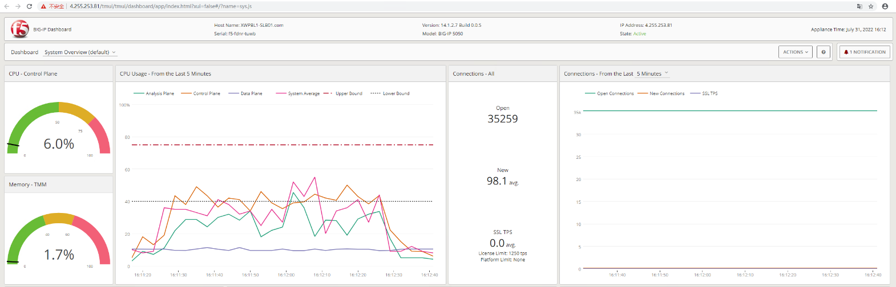
点击Statistics->Dashboard

点击Local Traffic->Pools->选择对应的Pool->Statistics
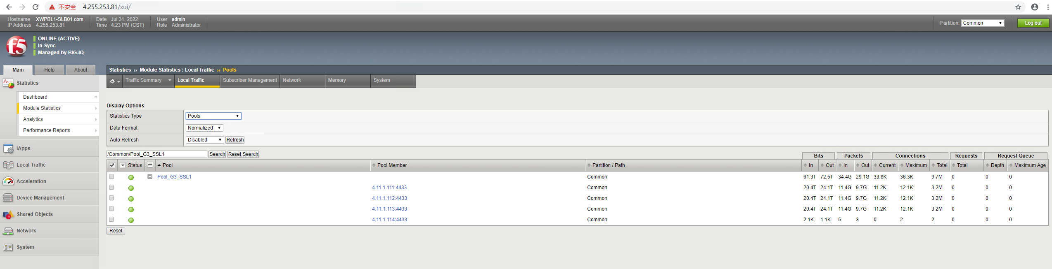

      - SSL网关
详见《SSL网关假活排查手册》
    - 应急处理步骤
生产所有硬件设备都有冗余，第一时间进行关闭隔离。

- 外部链路
外部链路分类：
- 西五环内联接入区接入区省中心的数据端、管理端线路。
- 西五环二中心、亦庄二期外连接区第三方线路。
- 西五环互联网A区电信、联通、移动的BGP线路。
- 西五环互联网B区电信、联通、移动的本地互联网线路。
- 数据中心互联裸光。
- 省中心LNS互联网线路。（由省中心维护）
业务承载：
序号 | 类型 | 接入区 | 业务描述 | 业务等级
1 | 省中心专线 | 二中心内联网接入区 | VPDN传统终端售票 | 1
2 | BGP互联网 | 二中心互联网A区 | 各省市TLS终端售票，兑奖 | 1
 |  |  | ILMS(即开管理端第三方接口) | 3
 |  |  | 帷胜决策系统 | 不定级
 |  |  | 即开移动端业务 | 3
 |  |  | 安卓终端 | 1
3 | 本地互联网 | 二中心互联网B区 | 统一业务监控平台 | 3
 |  |  | 实体渠道应用(web) | 3
 |  |  | ump单向认证首页 | 3
 |  |  | ump证书双向认证界面 | 3
 |  |  | 即开流程管理子系统 | 3
 |  |  | 体彩APPSFTP文件服务器 | 3
 |  |  | 支付系统：缓存 | 3
 |  |  | 支付系统：注册、登录、信息查询、投注 | 3
 |  |  | 支付系统：交易相关 | 3
 |  |  | 支付系统：用户中心相关 | 3
 |  |  | 支付系统：开放API | 3
 |  |  | 支付系统：验票网站 | 3
 |  |  | 安卓终端相关系统 | 3
 |  |  | 数据中台 | 3
 |  |  | 开放平台 | 3
 |  |  | 信息发布平台 | 3
 |  |  | 运行研发移动端业务 | 3
 |  |  | 帷胜决策系统v3.0 | 不定级
 |  |  | 实体渠道 | 3
 |  |  | 拉新 | 3
 |  |  | 骏彩业务竞猜监控版本 | 3
 |  |  | 骏彩业务竞猜数据分析服务 | 3
 |  |  | 机构用户安全接入平台 | 3
4 | 数据中心互联 | 翌景-亦庄裸光 | 翌景BOCC赛事运营、翌景6层开奖、支付系统建行银联专线、科技和技术中心办公网 | 1
 |  | 亦庄-西五环裸光 | ECC运维终端及监控大屏、腾讯云（G3系统售票、信息发布中心、开放平台、账户投注、财富中心）、数据中台 | 1

- 检查方式
      - 查看设备硬件状态
按照设备硬件故障命令查看。
      - 查看设备NQA日志
<XWPCRT01>display logbuffer
NQA entry js js probe fail trap information: pingCtlOwnerIndex: js, pingCtlTestName: js, pingCtlTargetAddressType: 1, pingCtlTargetAddress: 172.7.32.6, pingResultsOperStatus: 1, pingResultsIpTargetAddressType: 0, ping[non auto switch]

      - 查找对应端口
<XWPCRT01>display interface description
PHY: Physical
*down: administratively down
^down: standby
(l): loopback
(s): spoofing
(E): E-Trunk down
(b): BFD down
(B): Bit-error-detection down
(e): ETHOAM down
(d): Dampening Suppressed
(p): port alarm down
(ld): loop-detect trigger down
Interface PHY Protocol Description
Eth-Trunk3 up up To XWPASW03-Eth-Trunk1
GE0/0/0 up up Out-Of-Band-Management
GE1/0/0 up up XWPCRT01_to_QH-LNS-1_G1/0/4_CT_DATA_MSTP_8M_BJ_QH_ETN2104NP
GE1/0/1 up up XWPCRT01_to_HI-LNS-1_G3/1/3_CT_DATA_MSTP_2M_BJ_HI_ETN2138NP
GE1/0/2 up up XWPCRT01_to_HN-LNS-1_F0/1/5_CT_DATA_MSTP_6M_BJ_HN_ETN2247NP
GE1/0/3 up up XWPCRT01_to_JX-LNS-1_G3/1/5_CT_DATA_MSTP_6M_BJ_JX_ETN2172NP
GE1/0/4 up up XWPCRT01_to_FJ-LNS-1_G//_CT_DATA_MSTP_24M_BJ_FJ_ETN2208NP
      - 查看接口状态
端口状态“up”表示端口正常，“down”表示端口中断，可关注CRC参数，过多的CRC数量表示该端口或线路物理层面有问题。
<XWPCRT01>display interface GigabitEthernet 1/0/0
GigabitEthernet1/0/0 current state : UP (ifindex: 72)
Line protocol current state : UP
Last line protocol up time : 2021-04-15 18:39:50+08:00
Link quality grade : GOOD
Description: XWPCRT01_to_QH-LNS-1_G1/0/4_CT_DATA_MSTP_8M_BJ_QH_ETN2104NP
Route Port,The Maximum Transmit Unit is 1500
Internet Address is 172.7.63.1/30
IP Sending Frames' Format is PKTFMT_ETHNT_2, Hardware address is e868-1933-2572
The Vendor PN is LTD1302-BC+1
The Vendor Name is Hisense
Port BW: 1G, Transceiver max BW: 1G, Transceiver Mode: SingleMode
WaveLength: 1310nm, Transmission Distance: 10km
Rx Power: -3.33dBm, Warning range: [-20.000, -2.999]dBm
Tx Power: -6.19dBm, Warning range: [-8.999, -2.999]dBm
Loopback: none, full-duplex mode, negotiation: disable, Pause Flowcontrol: Receive Enable and Send Enable
Last physical up time : 2021-04-15 18:39:50+08:00
Last physical down time : 2021-04-15 18:21:36+08:00
Current system time: 2022-07-28 21:05:47+08:00
Statistics last cleared:2019-08-02 09:55:46+08:00
Last 300 seconds input rate: 63455 bits/sec, 37 packets/sec
Last 300 seconds output rate: 68285 bits/sec, 31 packets/sec
Input peak rate 2028671 bits/sec, Record time: 2020-10-12 10:10:01+08:00
Output peak rate 4870734 bits/sec, Record time: 2019-12-20 10:12:07+08:00
Input: 545786316772 bytes, 2516030764 packets
Output: 553594234246 bytes, 2122980348 packets
Input:
Unicast: 2516030689 packets, Multicast: 45 packets
Broadcast: 30 packets, JumboOctets: 3 packets
CRC: 0 packets, Symbol: 0 packets
Overrun: 0 packets, InRangeLength: 0 packets
LongPacket: 0 packets, Jabber: 0 packets, Alignment: 0 packets
Fragment: 0 packets, Undersized Frame: 0 packets
RxPause: 0 packets
Output:
Unicast: 2088553404 packets, Multicast: 3128303 packets
Broadcast: 31298641 packets, JumboOctets: 5028800 packets
Lost: 0 packets, Overflow: 0 packets, Underrun: 0 packets
System: 0 packets, Overruns: 0 packets
TxPause: 0 packets
Last 300 seconds input utility rate: 0.01%
Last 300 seconds output utility rate: 0.01%
      - 查找对端IP地址
可参考《广域网线路表》。
<XWPCRT01>display ip interface brief
*down: administratively down
!down: FIB overload down
^down: standby
(l): loopback
(s): spoofing
(d): Dampening Suppressed
(E): E-Trunk down
The number of interface that is UP in Physical is 80
The number of interface that is DOWN in Physical is 36
The number of interface that is UP in Protocol is 77
The number of interface that is DOWN in Protocol is 39

Interface IP Address/Mask Physical Protocol VPN
Eth-Trunk3 4.255.199.33/30 up up --
GigabitEthernet0/0/0 4.255.253.3/24 up up l3vpn
GigabitEthernet1/0/0 172.7.63.1/30 up up --
GigabitEthernet1/0/1 172.7.46.1/30 up up --
GigabitEthernet1/0/2 172.7.43.1/30 up up --
GigabitEthernet1/0/3 172.7.36.1/30 up up --
GigabitEthernet1/0/4 172.7.35.1/30 up up --

      - 测试联通性
（“Reply from x.x.x.x: bytes=56 Sequence=1 ttl=64 time=52 ms”表示连通，“Request time out”表示不通）。
<XWPCRT01>ping 172.7.63.3
PING 172.7.63.3: 56 data bytes, press CTRL_C to break
Reply from 172.7.63.3: bytes=56 Sequence=1 ttl=255 time=2 ms
Reply from 172.7.63.3: bytes=56 Sequence=2 ttl=255 time=1 ms
Reply from 172.7.63.3: bytes=56 Sequence=3 ttl=255 time=1 ms
Reply from 172.7.63.3: bytes=56 Sequence=4 ttl=255 time=1 ms
Reply from 172.7.63.3: bytes=56 Sequence=5 ttl=255 time=1 ms

--- 172.7.63.3 ping statistics ---
5 packet(s) transmitted
5 packet(s) received
0.00% packet loss
round-trip min/avg/max = 1/1/2 ms

<XWPCRT01>ping 172.7.63.4
PING 172.7.63.4: 56 data bytes, press CTRL_C to break
Request time out
Request time out
Request time out
Request time out

--- 172.7.63.4 ping statistics ---
4 packet(s) transmitted
0 packet(s) received
100.00% packet loss

- 应急处理步骤
- 根据《广域网线路表》确认线路专线号，拨打相关网络运营商故障受理电话进行线路故障申报；省中心LNS互联网线路由省中心负责报障。
- 线路恢复正常后，需进行连通性测试，使用扩展ping命令，数据包大小至少1500字节，数量至少100个；

- 路由
根据明细地址段路由可以判定可能受影响的业务类型，主要的地址段对应业务类型如下：
分类 | 地址范围 | 所属BL | 应用
安全 | 4.10.1.0 | 生产1区 | PKI
 | 4.12.0.0 | 生产1区 | 交易系统安全服务
 | 4.11.1.0 | 生产1区 | 终端安全接入第1组SSL
 | 4.11.2.0 | 生产1区 | 终端安全接入第2、3组SSL
 | 4.11.3.0 | 生产1区 | 终端安全接入第4、5组SSL
 | 4.11.0.0 | 生产1区 | 证书作废列表服务器
 | 4.13.1.0 | 生产1区 | 终端UMP导入
 | 4.13.10.0 | 生产1区 | webseal接入
 | 4.10.10.0 | 生产1区 | CIMS
 | 4.20.10.0 | 生产2区 | CIMS管理
 | 4.20.0.0 | 生产2区 | 病毒管理
loopback1 | 4.255.255.0 |  | 设备第一个loopback地址
loopback2 | 4.255.254.0 |  | 设备第二个loopback地址
互联地址段1 | 4.255.200.0 |  | 互联地址
互联地址段2 | 4.255.199.0 |  | 内联网接入区互联地址
互联地址段3 | 4.255.198.0 |  | 生产服务器1区互联地址
互联地址段4 | 4.255.197.0 |  | 生产服务器2区互联地址
互联地址段5 | 4.255.196.0 |  | 管理服务器区互联地址
互联地址段6 | 4.255.195.0
互联地址段7 | 4.255.194.0
互联地址段8 | 4.255.193.0 |  | 互联网接入B区互联地址
互联地址段9 | 4.255.192.0 |  | 互联网接入A区互联地址
互联地址段10 | 4.255.191.0 |  | 外联网接入区互联地址
互联地址段11 | 4.255.190.0
设备管理 | 4.255.253.0 | 管理 | 网络设备
 | 4.255.250.0 | 管理 | 系统-服务器设备带外管理1
 | 4.255.249.0 | 管理 | 系统-服务器设备带外管理2
 | 4.255.248.0 | 管理 | 系统-服务器设备带外管理3
 | 4.255.247.0 | 管理 | 数据集成平台带外管理
 | 4.255.246.0 | 管理 | 系统-存储设备管理1
 | 4.255.245.0 | 管理 | 系统-存储设备管理2
 | 4.255.244.0 | 管理 | 系统-NAS存储数据
 | 4.255.243.0 | 管理 | 系统-小型机管理1
 | 4.255.242.0 | 管理 | 系统-小型机管理2
 | 4.255.241.0 | 管理 | 系统-小型机管理3
 | 4.255.240.0 | 管理 | 安全设备
 | 4.255.252.0 | 管理 | 网络设备
 | 4.255.239.0 | 管理 | 安全PKI设备
安全OCS | 4.255.10.0 | 管理 | 安全OCS
G3管理 | 4.255.238.0 | 管理 | G3管理
G3管理 | 4.255.237.0 | 管理 | G3管理
G3管理 | 4.255.236.0 | 管理 | G3管理
安全SOC | 4.255.235.0 | 管理 | 安全SOC
虚拟化（云平台） | 4.255.230.0 | 管理 | 服务器ESXi管理1
 | 4.255.229.0 | 管理 | 服务器vMotion地址
 | 4.255.228.0 | 管理 | 服务器备份线路
 | 4.255.227.0 | 管理 | NAS存储连接地址
系统基础环境 | 4.255.220.0 | 管理 | 系统基础环境1（云平台管理）
 | 4.255.219.0 | 管理 | 系统基础环境2
 | 4.255.218.0 | 管理 | 系统基础环境3
 | 4.255.217.0 | 管理 | 系统基础环境4
自动化运维 | 4.255.210.0 | 管理 | 自动化运维
监控 | 4.255.209.0 | 管理 | IT基础监控
 | 4.255.208.0 | 管理 | 智能运维平台
 | 4.255.207.0 | 管理 | 运维大数据1
 | 4.255.206.0 | 管理 | 运维大数据2
 | 4.255.205.0 | 管理 | 应用运维
 | 4.255.201.0 | 管理 | 网络运维
预留地址 | 4.255.202-204.0
系统基础环境 | 4.255.100.0 | 管理 | 自动化装机
虚拟化（云平台） | 4.100.220.254 | 管理 | 云平台ESXI
运维平台 | 4.127.5.254 | 生产1区 | 运维平台Zabbix
SOC | 4.127.31.254 | 生产1区 | SOC业务
SOC | 4.127.32.254 | 生产1区 | SOC业务
基础服务 | 4.8.0.0/24 | 生产接入区 | DNS
基础服务 | 4.9.0.0/24 | 生产1区 | 时间服务器
基础服务 | 4.9.1.0/24 | 生产1区 | 系统组管理类应用
基础服务 | 4.9.5.0/24 | 生产1区 | SFTP
基础服务 | 4.9.6.0/24 | 生产1区 | 研发-jenkins服务器
基础服务 | 4.9.7.0/24 | 生产1区 | 量子随机数
运维平台 | 4.254.0.0/16 | 管理 | 运维平台
交易业务 | 4.11.5.0/24 | 生产1区 | 各种PROXY代理
交易业务 | 4.11.9.0/24 | 生产1区 | 导库服务器
交易业务 | 4.11.10.0/24 | 生产1区 | 发行管理平台SIE第1组
交易业务 | 4.11.20.0/24 | 生产1区 | 发行管理平台SIE第2组
交易业务 | 4.11.30.0/24 | 生产1区 | 发行管理平台SIE第3组
交易业务 | 4.11.40.0/24 | 生产1区 | 发行管理平台SIE第4组
交易业务 | 4.11.50.0/24 | 生产1区 | 发行管理平台SIE第5组
交易业务 | 4.11.70.0/24 | 生产1区 | 二代纸质即开SIE
交易业务 | 4.11.80.0/24 | 生产1区 | 电彩平台SIE
交易业务 | 4.11.90.0/24 | 生产1区 | 互联网新渠道SIE
交易业务 | 4.12.1.0/24 | 生产1区 | 发行管理平台-ATS
交易业务 | 4.12.10.0/24 | 生产1区 | CTP第1组应用服务器
交易业务 | 4.12.20.0/24 | 生产1区 | CTP第2组应用服务器
交易业务 | 4.12.30.0/24 | 生产1区 | CTP第3组应用服务器
交易业务 | 4.12.40.0/24 | 生产1区 | CTP第4组应用服务器
交易业务 | 4.12.50.0/24 | 生产1区 | CTP第5组应用服务器
交易业务 | 4.12.11.0/24 | 生产1区 | 发行管理平台第一组数据库
交易业务 | 4.12.21.0/24 | 生产1区 | 发行管理平台第二组数据库
交易业务 | 4.12.31.0/24 | 生产1区 | 发行管理平台第三组数据库
交易业务 | 4.12.41.0/24 | 生产1区 | 发行管理平台第四组数据库
交易业务 | 4.12.51.0/24 | 生产1区 | 发行管理平台第五组数据库
交易业务 | 4.12.61.0/24 | 生产1区 | 降级、对账数据库
即开游戏交易业务 | 4.12.70.0/24 | 生产1区 | 即开游戏应用服务器
即开游戏交易业务 | 4.12.71.0/24 | 生产1区 | 即开游戏数据库服务器
即开游戏促销 | 4.12.72.0/24 | 生产1区 | 即开游戏促销
交易业务 | 4.13.5.0/24 | 生产1区 | 彩银
交易业务 | 4.13.11.0/24 | 生产1区 | 发行管理平台归集数据库
强管制系统 | 4.13.20.0/24 | 生产1区 | 强管制系统
即开管理服务 | 4.13.70.0/24 | 生产1区 | 即开管理服务
交易业务 | 4.16.10.0/24 | 生产1区 | 基诺第1组应用服务器
交易业务 | 4.16.20.0/24 | 生产1区 | 基诺第2组应用服务器
交易业务 | 4.16.30.0/24 | 生产1区 | 基诺第3组应用服务器
交易业务 | 4.16.40.0/24 | 生产1区 | 基诺第4组应用服务器
交易业务 | 4.16.50.0/24 | 生产1区 | 基诺第5组应用服务器
交易业务 | 4.16.60.0/24 | 生产1区 | 基诺第6组应用服务器
交易业务 | 4.16.70.0/24 | 生产1区 | 基诺第7组应用服务器
交易业务 | 4.16.11.0/24 | 生产1区 | 基诺第1组数据库服务器
交易业务 | 4.16.21.0/24 | 生产1区 | 基诺第2组数据库服务器
交易业务 | 4.16.31.0/24 | 生产1区 | 基诺第3组数据库服务器
交易业务 | 4.16.41.0/24 | 生产1区 | 基诺第4组数据库服务器
交易业务 | 4.16.51.0/24 | 生产1区 | 基诺第5组数据库服务器
交易业务 | 4.16.61.0/24 | 生产1区 | 基诺第6组数据库服务器
交易业务 | 4.16.71.0/24 | 生产1区 | 基诺第7组数据库服务器
交易业务 | 4.16.0.0/24 | 生产1区 | 基诺公共服务
交易业务 | 4.17.10.0/24 | 生产1区 | 竞彩奖金查询（SIH）
基础服务 | 4.20.1.0/24 | 生产2区 | SFTP
监管系统 | 4.20.25.0/24 | 生产2区 | 监管系统
监管系统 | 4.20.26.0/24 | 生产2区 | 监管系统
监管系统 | 4.20.27.0/24 | 生产2区 | 业务监管
实体渠道 | 4.24.10.0/24 | 生产2区 | 实体渠道
实体渠道 | 4.24.11.0/24 | 生产2区 | 实体渠道-SDK地图
实体渠道 | 4.24.12.0/24 | 生产2区 | 实体渠道-业主端
实体渠道 | 4.24.13.0/24 | 生产2区 | 实体渠道-实名认证
用户拉新 | 4.27.10.0/24 | 生产2区 | 用户拉新
网点感知系统 | 4.27.11.0/24 | 生产2区 | 网点感知系统/数据集成平台报表集市项目
机构用户安全接入 | 4.27.13.0/24 | 生产2区 | 机构用户安全接入
区块链 | 4.27.31.0/24 | 生产2区 | 区块链
信息发布 | 4.27.41.0/24 | 生产2区 | 信息发布
AW系统 | 4.50.10.0/24 | 生产2区 | AW系统
二中心ECC | 4.30.11.0/24 | 管理 | 二中心ECC
外联网区 | 4.101.0.0/16 | 外联网区 | 外联网区
互联网A区 | 4.102.0.0/16 | 互联网A区 | 互联网A区
互联网B区 | 4.103.0.0/16 | 互联网B区 | 互联网B区
G3营销中心 | 4.28.10.0/24 | 生产2区 | G3营销中心
G3财务中心 | 4.28.20.0/24 | 生产2区 | G3财务中心
G3财务运营系统 | 4.28.30.0/24 | 生产2区 | G3财务运营系统
数据集成平台 | 4.14.100.0/24 | 生产1区 | 数据集成平台
即开流程子系统 | 4.20.50.0/24 | 生产2区 | 即开流程子系统
即开前置 | 4.26.10.0/24 | 生产2区 | 即开前置
G3业务 | 4.60.0.0/16 | G3区域 | G3业务
数据集成平台 | 4.35.10.0/24 | 生产2区 | 数据集成平台
数据集成平台 | 4.14.10.0/24 | 生产1区 | 数据集成平台SFTP
竞猜系统 | 4.190.40.0/22 | 网关区
竞猜系统 | 4.190.44.0/22 | 网关区
竞猜系统 | 4.190.80.0/22 | 核心区
竞猜系统 | 4.190.84.0/22 | 核心区
竞猜系统 | 4.190.120.0/22 | 管理区
竞猜系统 | 4.190.123.0/22 | 管理区
竞猜系统 | 4.191.40.0/21 | 公共区 | NAS业务网段
竞猜系统 | 4.191.48.0/21 | 公共区 | ISCSI业务网段
竞猜系统 | 4.191.240.0/21 | 公共区 | Vmkernal
竞猜系统 | 4.191.232.0/21 | 公共区 | Vmotion
竞猜系统 | 4.176.28.0/24 | 带外区 | 网络监控（Solarwinds）
竞猜系统 | 4.177.0.0/16 | 公共区 | 备份
竞猜系统 | 4.191.248.0/24 | 带外区 | 服务器ILO
竞猜系统 | 4.191.249.0/24 | 带外区 | 存储设备管理
竞猜系统 | 4.176.0.0/24 | 带外区 | 网络设备（交换机、路由器、防火墙）带外管理
竞猜系统 | 4.176.1.0/24 | 带外区 | 负载均衡、安全设备带外管理

- 检查方式
      - 检查OSPF的邻居关系
显示state为full时属于正常状态，显示为idle、twoway、exchange等状态均为异常。
        - 华为设备：
<XWHPCSW01>dis ospf peer
OSPF Process 10 with Router ID 0.193.212.201
Area 0.0.0.0 interface 4.255.200.1 (Eth-Trunk1)'s neighbors
Router ID: 4.255.255.21 Address : 4.255.200.2
State : Full Mode : Nbr is Master Priority: 1
DR : None BDR : None MTU : 0
Dead timer due (in seconds) : 35
Retrans timer interval : 5
Neighbor up time : 20292h18m44s
Neighbor up time stamp : 2019-11-08 04:36:43+08:00
Authentication Sequence : 0

Area 0.0.0.0 interface 4.255.200.9 (Eth-Trunk2)'s neighbors
Router ID: 4.255.255.22 Address : 4.255.200.10
State : Full Mode : Nbr is Master Priority: 1
DR : None BDR : None MTU : 0
Dead timer due (in seconds) : 32
Retrans timer interval : 5
Neighbor up time : 20292h18m47s
Neighbor up time stamp : 2019-11-08 04:36:38+08:00
Authentication Sequence : 0

Area 0.0.0.0 interface 4.255.200.17 (Eth-Trunk3)'s neighbors
Router ID: 4.255.255.23 Address : 4.255.200.18
        - 华三设备：
<XWHPD-NC1COL-SW01>dis ospf peer

OSPF Process 2000 with Router ID 4.176.4.6
Neighbor Brief Information

Area: 0.0.0.0
Router ID Address Pri Dead-Time State Interface
4.176.4.8 4.176.12.113 1 39 Full/BDR Vlan3028
4.176.6.17 4.176.12.65 1 34 Full/DR Vlan3016
4.176.6.18 4.176.12.69 1 35 Full/DR Vlan3017
4.176.6.19 4.176.12.73 1 35 Full/DR Vlan3018
4.176.6.20 4.176.12.77 1 35 Full/DR Vlan3019
4.176.6.21 4.176.12.81 1 35 Full/DR Vlan3020
4.176.6.22 4.176.12.85 1 35 Full/DR Vlan3021
4.176.6.23 4.176.12.89 1 40 Full/BDR Vlan3022
4.176.6.24 4.176.12.93 1 40 Full/BDR Vlan3023
4.176.6.25 4.176.12.97 1 40 Full/BDR Vlan3024
4.176.6.26 4.176.12.101 1 40 Full/BDR Vlan3025
4.176.6.27 4.176.12.105 1 40 Full/BDR Vlan3026
4.176.4.3 4.176.12.110 1 35 Full/BDR Vlan3027

      - 检查相应的路由学习情况
输出相应的路由条目属于正常，否则不正常。
        - 华为设备：
<XWHPCSW01>dis ip routing-table 3.20.10.21
Proto: Protocol Pre: Preference
Route Flags: R - relay, D - download to fib, T - to vpn-instance, B - black hole route
------------------------------------------------------------------------------
Routing Table : _public_
Summary Count : 1
Destination/Mask Proto Pre Cost Flags NextHop Interface
3.20.10.21/32 Static 60 0 RD 4.255.253.254 MEth0/0/0
        - 华三设备：
<XWHPD-NC1COL-SW01>dis ip routing-table 4.9.5.1
Summary count : 4
Destination/Mask Proto Pre Cost NextHop Interface
4.9.0.0/16 Static 60 0 4.255.200.65 XGE2/3/0/1
4.255.200.69 XGE1/3/0/1
4.9.5.1/32 Static 60 0 4.255.200.65 XGE2/3/0/1
4.255.200.69 XGE1/3/0/1

- 应急处理步骤
路由故障多为硬件故障导致，应第一时间对硬件故障进行隔离使其自行恢复，对于其他个例情况视情况而定可采用静态路由临时恢复主要业务，根据路径由源端至目的端逐跳添加静态路由。

- 负载均衡
- 检查方式
      - 检查VS地址健康状况
点击Local Traffic->Virtual Servers，Status显示绿色为正常状态，显示红色为异常状态。
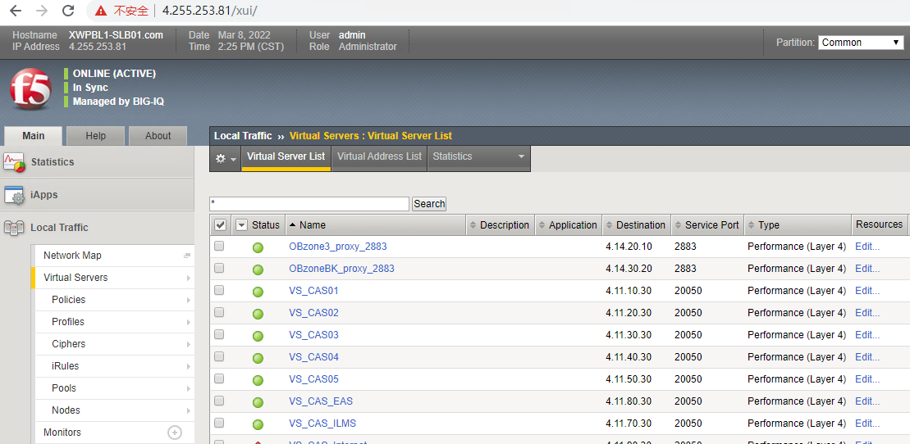

      - 检查Pool地址池健康状况
点击Local Traffic->Pools，Status显示绿色为正常状态，显示红色为异常状态。
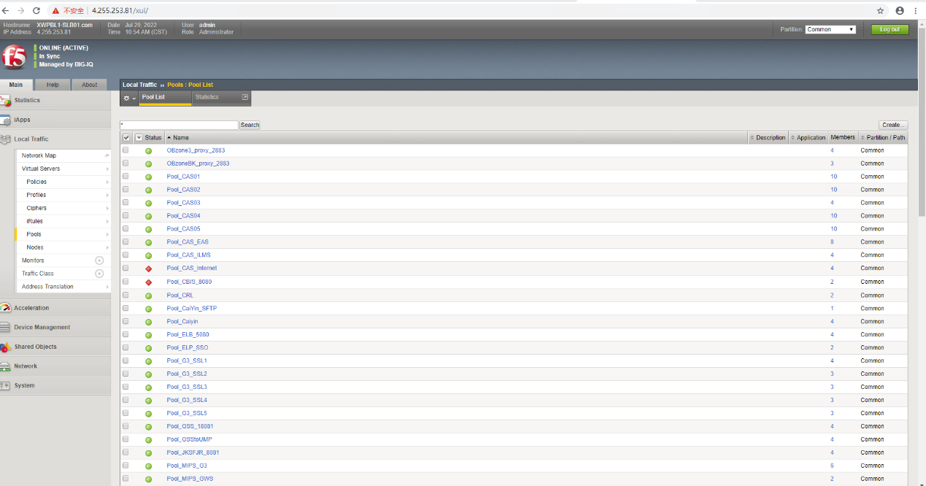

      - 检查相关Pool member成员连接的负载情况
正常情况Session分布基本平均，如出现分布非常不平均（超过50%差异），则低连接数对应的服务可能存在问题。点击Main-> Local Traffic-> Pools->选择对应Pool->statistics，查看Connections中Current Session分布。
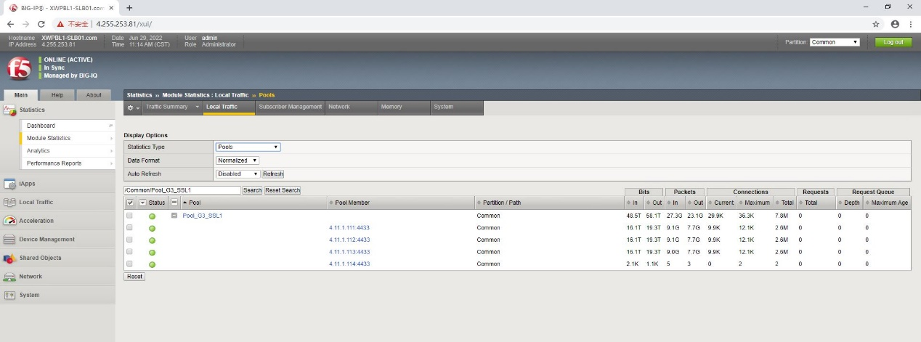
- 应急处理步骤
1、F5为双机或集群热备，如果主设备出现问题或硬件故障可自动或手动切换到备设备上恢复业务。
2、如发现异常服务器需要在F5上对其进行隔离，隔离步骤如下：
（1）点击Local Traffic-> Pools，选择对应的Pool。
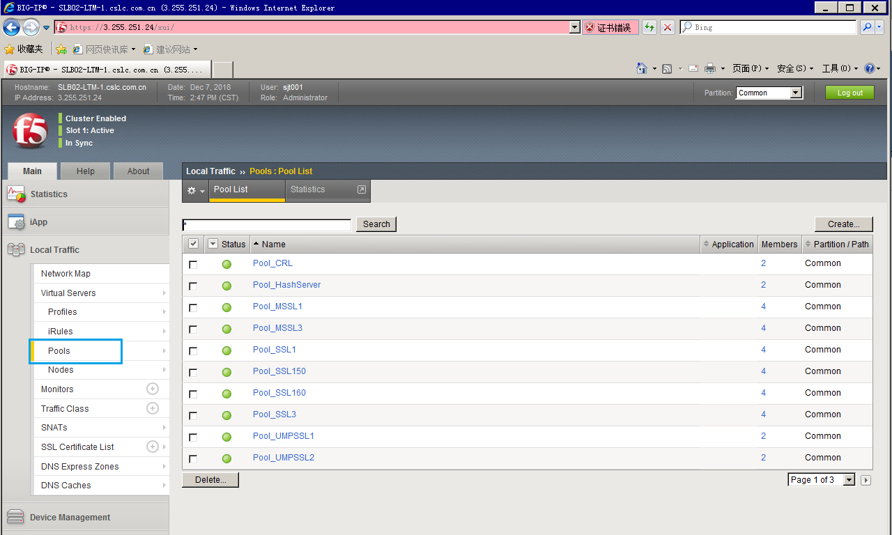

（2）选择Pool里需要隔离的member点击disable。
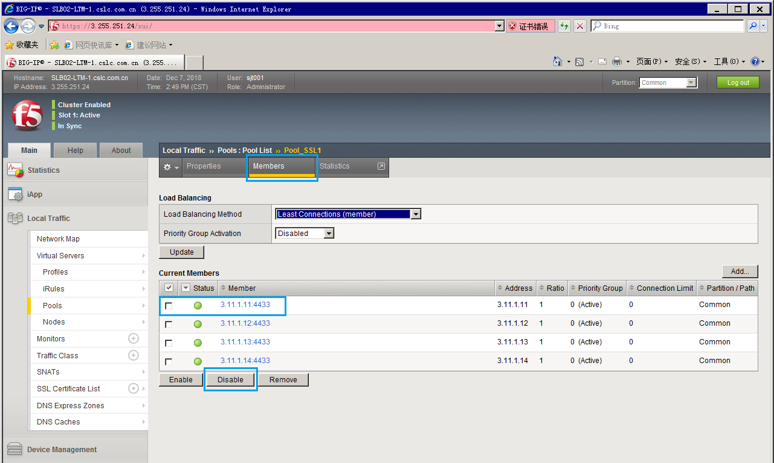

（3）把配置信息同步到其他F5
